**JECRC**

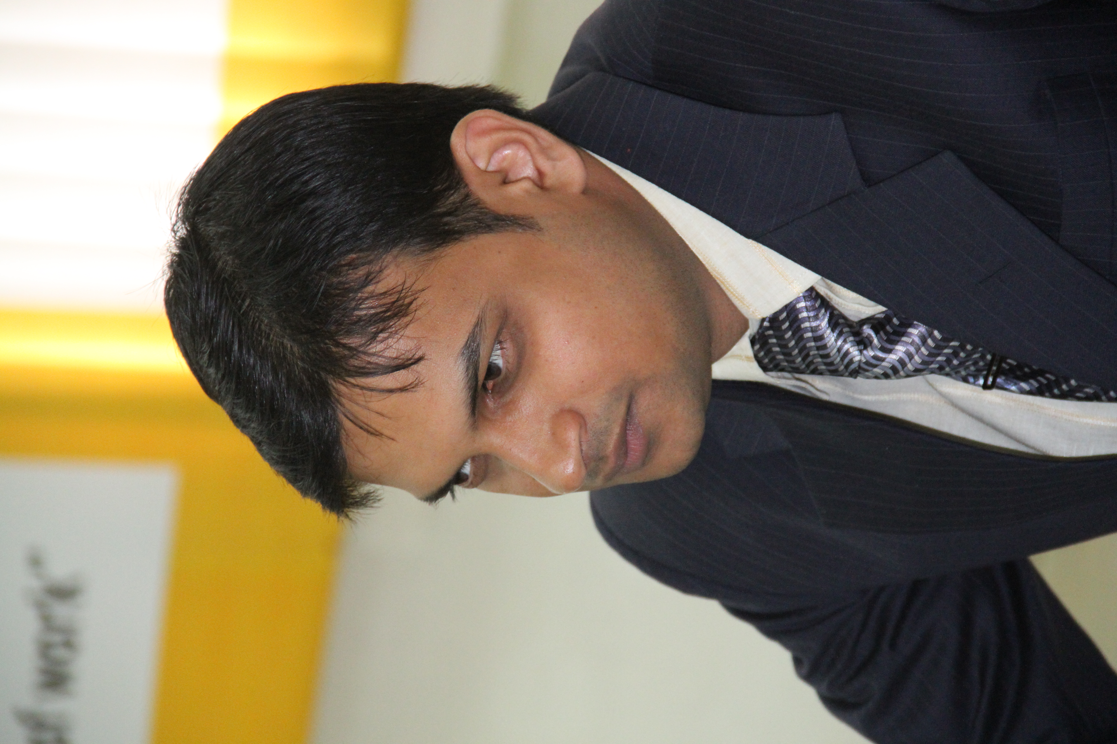

**JAIPUR**

**INDIVIDUAL FACULTY DATA SHEET**

|  |  |  |
| --- | --- | --- |
| **Name of the faculty member** | **:** | Dr. Sandeep Vyas |
| **Present Designation** | **:** | Associate Professor |

**Email Id :** dr.sandeepvyas.ee@jecrc.ac.in

**Contact Details :** +91-9413965018

**I. Particulars of Educational Qualification: (*only completed*)**

|  |  |  |  |  |  |
| --- | --- | --- | --- | --- | --- |
| **Category** | **Name of the Degree** | **Specialization** | **Year of Passing** | **Name of the College** | **Name of the University** |
| **UG** | B.E. | Electronics and Communication Engineering | 2002 | Engineering College Ajmer, Ajmer | Rajasthan University |
| **PG** | M. Tech. | Electronics and Communication Engineering | 2006 | Malaviya National Institute of Technology (MNIT), Jaipur | Malaviya National Institute of Technology (MNIT), Jaipur |
| **Ph.D.** | Ph. D. | Electronics and Communication Engineering | 2017 | Malaviya National Institute of Technology (MNIT), Jaipur | Malaviya National Institute of Technology (MNIT), Jaipur |

**II. Academic Experience :** 16 Year

**III. Industrial Experience :** ------

**IV. Title of Ph.D. Thesis:** Mid-IR Supercontinuum Generation in Microstructured Optical Fibers

**V. Awards/Achievements :**

* Dr. Sandeep Vyas was delivered a **Lightning Talk** @ IEEE sponsored International Conference (ICACCI-2016), LNM Institute of Information Technology (LNMIIT), Jaipur.
* Dr. Sandeep Vyas was invited as the **subject expert** to deliver his speech on Faculty Development Program (FDP) was organized on "Photonic Integrated Devices & Systems" during 22nd to 26th November 2017 under the banner of E&ICT Academy in Malaviya National Institute of Technology ***(MNIT)*** Jaipur.
* Dr. Sandeep Vyas was invited to **chair the session** in International Conference on Optical & Wireless Technologies (OWT 2018) by Springer at Malaviya National Institute of Technology ***(*MNIT*)*** on March (18th-19th) 2018.
* Dr. Sandeep Vyas, was invited as the **subject expert** to give his speech on Faculty Development Program (FDP) was organized on "Advance in Communication Technology" during 9th to 14th February 2018 under the banner of E & ICT Academy in Malaviya National Institute of Technology ***(MNIT)*** Jaipur.
* Gate Percentile in the year 2003 is **92.54**

**VI. Research/Specialization :** Photonic Crystal Fiber (PCF), Supercontinuum Generation (SCG), Nonlinear optics (NLO)

**VII. Course Taught :** Electronics Devices and Circuits, Communication Systems, Digital Communication, Integrated Circuits and Applications, Electronics Measurement and Instrumentation, Fiber Optic Communication, Wireless Communications, Satellite Communication

**VIII. Refereed International Journal Publication :**

**SCI indexed journals :**

1. **S. Vyas**, T. Tanabe, M. Tiwari, and G. Singh, “*Ultraflat broadband supercontinuum in highly nonlinear Ge11.5As24Se64.5 photonic crystal fibres*”, Ukrainian Journal of Physical Optics, Volume 17, Issue 3, p. 132-139, 2016. DOI: 10.3116/16091833/17/3/132/2016.

Impact Factor: 1**.071**

Publisher: **Ukrainian Journal of Physical Optics**

1. **S. Vyas**, T. Tanabe, M. Tiwari, and G. Singh, “*A Chalcogenide Photonic Crystal Fiber for Ultraflat Mid-infrared Supercontinuum Generation*”, Chinese Optics Letter, Volume 14, Issue 12, p. 123201-1 - 123201-5, 2016. DOI: 10.3788/COL201614.123201.

Impact Factor: **1.899**

Publisher: **Optical Society of America (*OSA*)**

3) S. Kalra, **S. Vyas**, M. Tiwari, O. Buryy, G. Singh, “*Highly nonlinear multi-material Chalcogenide spiral photonic crystal fiber for Supercontinuum Generation*”, Acta Physica Polonica A journal.

Status: **Accepted** (To be publish in 2018)

Impact Factor: **0.469**

Publisher: [**Polska Akademia Nauk**](http://www.scimagojr.com/journalsearch.php?q=Polska%20Akademia%20Nauk&tip=pub) **(**[**Poland**](http://www.scimagojr.com/journalrank.php?country=PL)**)**

**IX. International Conference Proceeding :**

1. N. Yadav, C. Shah, and **S. Vyas**, “Using Electromyography (EMG) for Mobility” in International Conference on ‘VLSI, Communication and Network’ in International Conference on VLSI, Communication and Network-2011, IET, Alwar, December (24th-25th), 2011.
2. U. Verma, and **S. Vyas**, “The large hadrons collider projects: It’s history, need, working, basic structure, it’s significance on today’s world and It’s applications” in International Conference on VLSI, Communication and Network-2011, IET, Alwar, December (24th-25th), 2011 .
3. **S. Vyas**, G. Singh, A. Goyal, H. K. Mangal, N. Choudhary, and S. Mathur“Modeling of a nano-metallic surface plasmonic lens for wider optical window operation” International Conference on Communication and Electronics System Design, Jaipur Proc. of **SPIE** Vol. 8760, 87601T, DOI: 10.1117/12.2012335, (2013).
4. **S. Vyas**, G. Singh, and M. Tiwari, “A Highly Nonlinear Photonic Crystal Fiber for Supercontinuum Generation” in international conference on ‘Thailand-Japan Microwave 2014’, **Bangkok** (Nov. 26-28), Thailand.
5. **S. Vyas**, G. Singh, and M. Tiwari, “Ultrabroad supercontinuum generation with different nonlinear material by novel structure of photonic crystal fibers” in international conference on ‘IKSS-2014’, Krutan (June 8-14), **Poland**,2014.
6. **S. Vyas**, G. Singh, M. Tiwari, and T. Tanabe, “Chalcogenide (LiGSe2, LiGISe, LiGaS2): A perfect material to design highly nonlinear PCFs for supercontinuum generation" Proc. of the ICRCWIP, DOI 10.1007/978-81-322-2638-2638-3_47, pp. 409–413, @**Springer Publication** 2016.
7. **S. Vyas**, G. Singh, and M. Tiwari, “A Highly Nonlinear Chalcogenide Based PCF for Mid–IR Supercontinuum Generation” in international conference on “International Conference on Optics & Photonics 2015 (**ICOP 2015**)”, Calcutta (Feb. 19, 2015), India.
8. **S. Vyas**, T. Tanabe, G. Singh, and M. Tiwari, “Broadband Supercontinuum Generation and Raman Response in Ge11.5As24Se64.5 based chalcogenide Photonic Crystal Fiber,” **IEEE International Conference** (ICCTICT-2016), pp. 562-566, March 2016. DOI:10.1109/ICCTICT.2016.7514651 .
9. **S. Vyas**, T. Tanabe, M. Tiwari, and G. Singh, “Mid-infrared supercontinuum generation in Ge11.5As24Se64.5 based chalcogenide photonic crystal fiber,” **IEEE International Conference** Advances in Computing, Communications and Informatics (ICACCI), pp. 2547-2552, September (21st-24th) 2016. DOI: 10.1109/ICACCI.2016.7732436
10. S. Kalra, **S. Vyas**, T. Ismail, M. Tiwari, and G. Singh, “Multi-material Photonic Crystal Fiber in MIR region for Broadband Supercontinuum Generation”, International Conference on Optical & Wireless Technologies (OWT 2017), pp. 199-209, March (18th-19th) 2017 @**Springer Publication**. DOI: 10.1007/978-981-10-7395-3_23.
11. S. Kalra, **S. Vyas**, M. Tiwari, G. Singh, “Numerical modeling of borosilicate doped photonic-crystal fiber for mid-IR supercontinuum generation” **IEEE International Conference** Progress In Electromagnetics Research Symposium-2017 (PIERS-2017), 19-22 November, 2017, **Singapore**. DOI:10.1109/PIERS-FALL.2017.8293418.
12. S. Kalra, **S. Vyas**, M. Tiwari, and G. Singh, “Supercontinuum generation at 3100 nm in dispersion engineered As38.8Se61.2 based chalcogenide photonic crystal fibers”, International Conference on Optical & Wireless Technologies (OWT 2018), pp. 199-209, February (10th -11th) 2018 @**Springer Publication**.

**X. Books Written :**

* “linear integrated circuits”, College Book Center, Jaipur.
* “Electronics Measurement and Instrumentation”, College Book Center, Jaipur.

**XI. M.Tech Thesis Guide :** 05

**XII. PHD Thesis Guide :** Nil

**XIII. Professional Body Membership:** IEEE, IEEE Photonics, LM ISTE, LM IETE, Optical Society of America (OSA)